Maximum Likelihood and Skin Color Detection

CS 479 Assignment 2

Ethan Brown, Ethan Park

Date Due: March 12, 2020

Date Handed In: March 12, 2020

Division of work:

Ethan Brown created the functions to estimate the mean and covariance matrices with a different number of random test samples using the maximum likelihood method. These functions were also used to generate the estimated mean and covariance matrices for skin color. He also updated the image processing files to work with color images as opposed to just black and white and plotted the ROC curves. For the report, Ethan Brown worked on the results and discussion section. Ethan Park set up the code and the files to generate the random samples and count the number of misclassifications. He also worked on reading in the data from the test images that was used to estimate the sample mean and covariance matrices for skin color along with generating the data to be plotted on the ROC curves. For the report Ethan Park worked on the theory, implementation, and source code.Table of Contents

## Theory................................................................................................ 3

### Problem 1.................................................................................... 3

### Problem 2.................................................................................... 4

### Problem 3.................................................................................... 4

## Implementation.................................................................................. 5

### Problem 1-2................................................................................. 5

### Problem 3.................................................................................... 5

## Results and discussion....................................................................... 6

### Problem 1.................................................................................... 6

### Problem 2.................................................................................... 8

### Problem 3.................................................................................... 11

## Source Code.......................................................................................16

## 

**Theory**

1

The first problem involves using the same 2D Gaussian distributions from problem one of the previous project assignment:

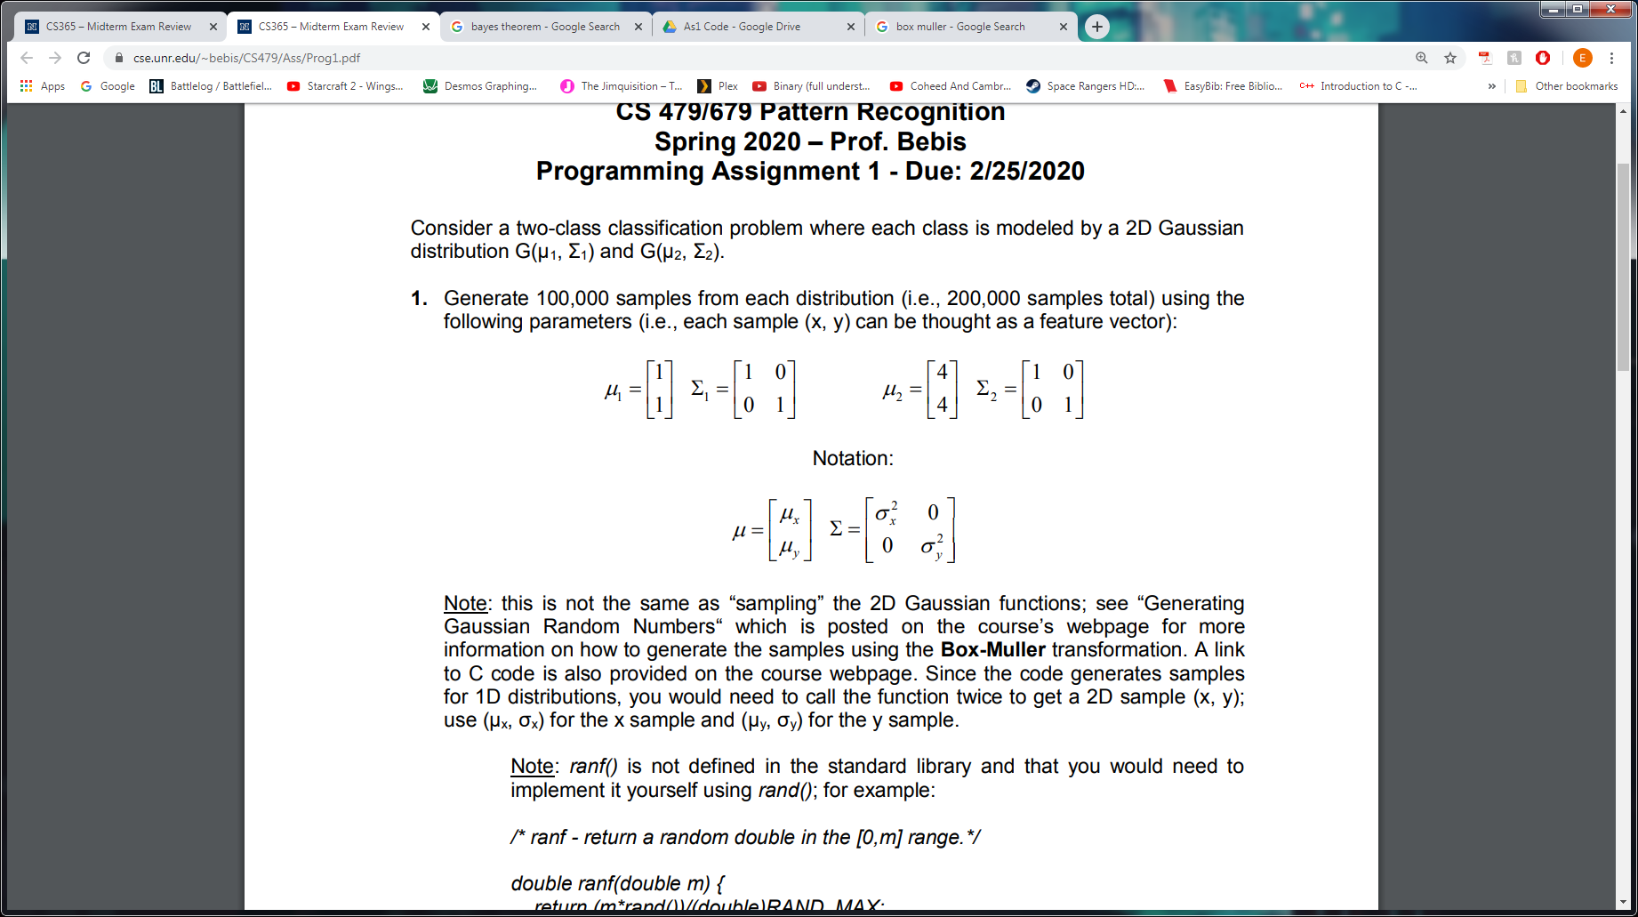

However, now it is assumed that the true parameters of the Gaussian distributions are not known and we are tasked with estimating them from the training data using the Maximum Likelihood (ML) approach.

When the ML approach is used, the parameters $θ$ are seen as fixed quantities whose values are known. $\hat{θ}$ represents the ML estimate for the data $D=x_{1},x_{2},...,x_{n}$ that maximizes the likelihood $p(D/θ)$:

$\hat{θ}=argmax_{θ}p(D/θ)$

$\hat{θ}$ can be estimated by maximizing the likelihood of obtaining the samples observed. In the case of this problem, we will be using the ML for multivariate Gaussian density for the case in which the case of the unknown is $θ=(μ,Σ)$. We use this specific ML as it will allow us to create estimates for mean and covariance of the given 2D Gaussian distributions. The solutions are given by

$\hat{μ}=$ $\frac{1}{n}$ $\sum_{k=1}^{n}{}$ $x_{k}$ for the sample mean

$\hat{Σ}=$ $\frac{1}{n}$ $\sum_{k=1}^{n}{}$ ${(x}_{k}-\hat{μ})(x_{k}-\hat{μ})^{t}$ for the sample covariance

The estimates for the mean and covariance matrices can then be used by Bayesian classifiers (the same exact way as the previous project assignment) to classify the data. Since the estimated variances are slightly different the third discriminant case will be used since the variances are arbitrary.

Part B involves repeating what was done in Part A but instead using varying percentages of the sample data. In theory, since ML gives more accurate estimates as the amount of training samples increases, using a lower percentage of the training data should yield worse results.

2

The second problem is similar to the first with the only aspect changing being the 2D Gaussian distributions:

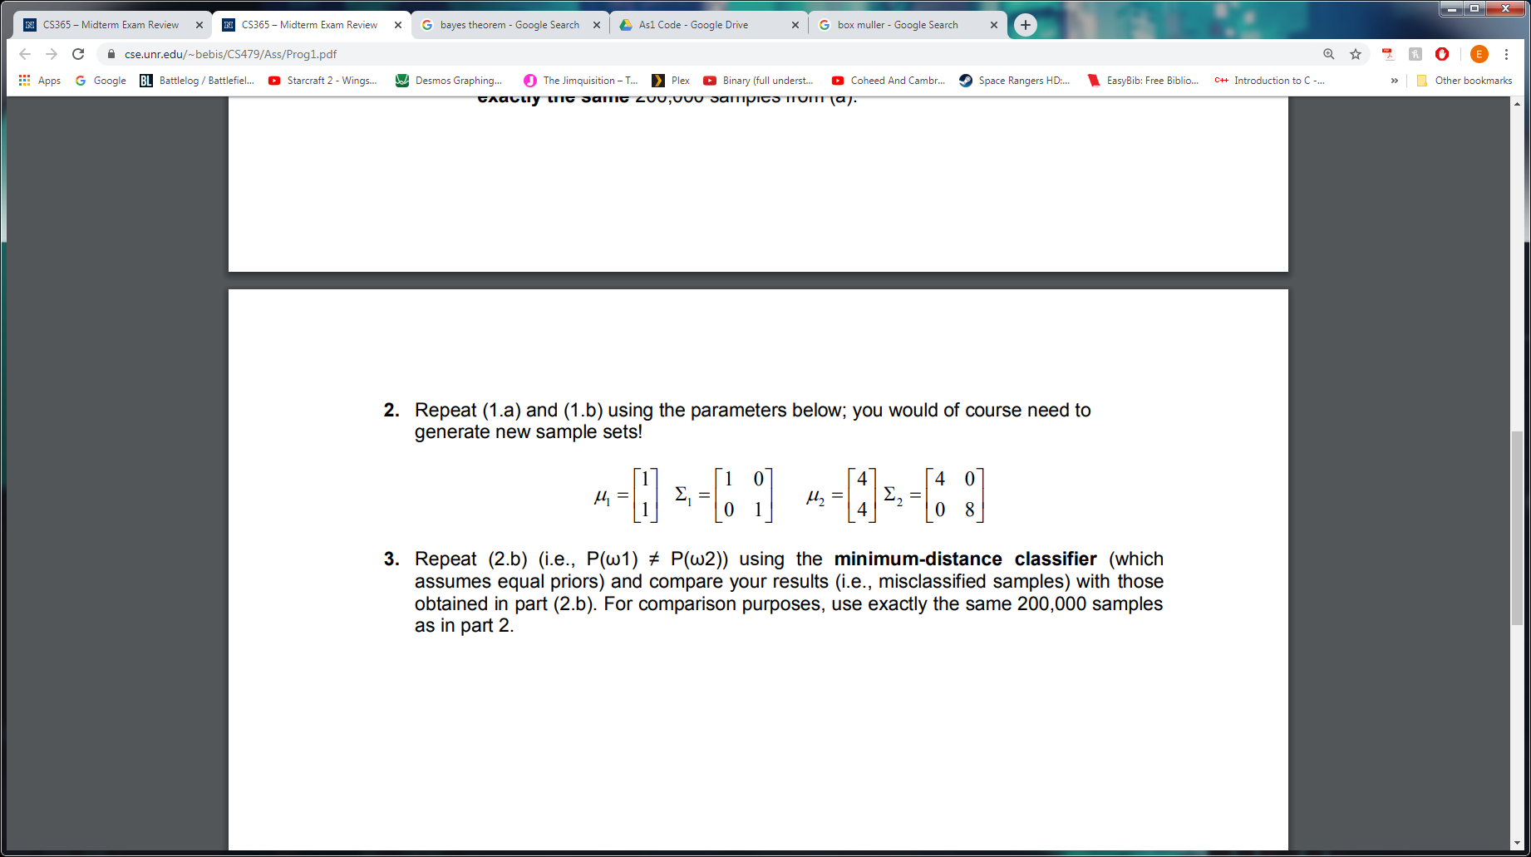

Most of the theory from question one remains the same. The estimated variances will no longer be slightly different (instead being even more different), however, this does not change the discriminant case as the variances are still arbitrary.

3

The third problem involves developing a classifier that implements face detection through the use of skin color. Part A requires us to use RGB color space to build and test the skin color model. In theory, skin color follows a peaked Gaussian distribution when observed with normalized color space values. RGB normalization formulas are given by

$Rnorm = R / (R+G+B)$

$Gnorm = G / (R+G+B)$

This information can be used with training data to create skin and non-skin distributions. We can then use these distributions to create estimates for mean and covariance using the the ML for multivariate Gaussian density for the case in which the case of the unknown is $θ=(μ,Σ)$ as was done in previous problems of this assignment. Finally, the estimates for mean and covariance can be used in the Bayesian Threshold Estimation equation

$g(x)=$ $\frac{1}{2π|Σ|^{1/2}}$ $exp[-$ $\frac{1}{2}$ $(x-μ)^{t}Σ^{-1}(x-μ)]$

$g(x)=$ $exp[-$ $\frac{1}{2}$ $(x-μ)^{t}Σ^{-1}(x-μ)]$

to determine whether a pixel should be classified as skin or non-skin.

Part B is similar to Part A except it requires us to use YCbCr () color space to build and test the skin color model. Instead of normalizing RGB color space we must normalize YCbCr color space which is given by the following equations

$Y = 0.299R+0.587G+0.114B$

$Cb = -0.169R-0.332G+0.500B$

$Cr = 0.500R-0.419G-0.081B$

The rest of the problem is similar to the theory in Part B except normalized YCbCr color space is used rather than normalized RGB color space.

**Implementation**

1 and 2

As in the previous project assignment, the Box-Muller Transformation functions were used to generate the random samples for the first and second problems. The two distributions were stored in Vector2f data structures (distribution1 and distribution2 respectively) in which the first float represents the x-coordinate and the second float represents the y-coordinate. The Eigen library was used again to store the matrices using the data structures Vector2f and Matrix2f. The function third discriminant case of the Bayesian classifier (discriminant_case_3) for the previous project assignment was reused. However, it was modified such that it now performs matrix calculations using the Vector2f and Matrix2f data structures. This change was made to simplify calculations. The functions ml_mean and ml_covariance were implemented and are used to estimate the sample mean and covariance for the distributions. ml_mean takes in the distribution (as a vector<Vector2f>) and the number of samples in the distribution (as int) as parameters. ml_covariance takes in the distribution (as vector<Vector2f>), the estimated mean (as Vector2f), and the number of samples in the distribution (as int) as parameters. The decisions made by the classifier was stored in a boolean array for each distribution with 0 (false) corresponding to the first distribution and 1 (true) corresponding to the second distribution.

3

For the third problem, we used the Image class as well as the image read (including read image header) and image write functions provided to read, write, and store images. The Vector2f data structures, skin_sample_data and skin_sample_data, were used to store the skin samples and non-skin samples respectively. The first float represents the normalized R value of RGB or the normalized Cb value of YCbCr while the second float represents the normalized G value of RGB or the normalized Cr value of YCbCr. As was the case in the previous problems Vector2f and Matrix2f were used to store the sample mean and covariance. These were again calculated using the ml_mean and ml_covariance function with the skin_sample_data and skin_sample_data being used as the distributions. To determine if a pixel should be classified as skin or non-skin, the function threshold_case_3 is used which implements the Bayesian Threshold Estimation equation. It takes in the normalized values (as Vector2f), the estimated mean (as Vector2f), the estimated covariance (as Matrix2f), and a threshold (as float).

**Results and Discussion**

1.a

Using the same 200,000 samples from the first part of assignment 1, we used the maximum likelihood method to estimate the parameters of each distribution. However, since the features did not have the exact same variance, we could no longer use the classifier for case 1 and instead had to use the classifier for case 3. Since we used all 200,000 samples to estimate the distributions, the results were very close to the expected results. Likewise, the number of misclassifications were very similar to that of assignment 1. In assignment 1, our classifier misclassified 3371 samples, and using our own distributions, there were 3363 misclassifications. The total number of misclassifications was very similar since the 2 distributions were almost identical. All this information can be seen in the terminal output in figure 1.

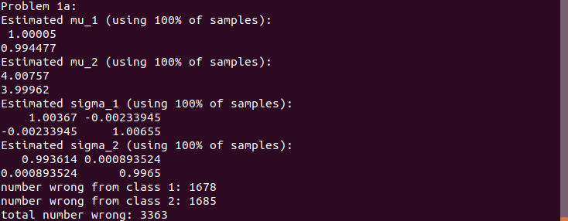

Figure 1 shows the terminal output for problem 1.a. It is clear to see that by using 100% of the samples, the estimated means and covariance matrices were very close to the expected results. Furthermore, since the priors were equal, the number of misclassifications for each class was nearly identical as well.

1.b

We repeated the tests from part 1.a by using smaller percentages of the 200,000 samples. We determined that as the number of samples used to estimate the distributions decreased, the number of misclassifications increased. Additionally, the estimated distributions differed from the expected value more and more with fewer samples. The results for the misclassifications can be seen in figure 2, and the estimated distributions can be seen in figure 3.

| Percentage of samples used | Number of total misclassifications |
| --- | --- |
| 0.01% | 4504 |
| 0.1% | 3419 |
| 1% | 3370 |
| 10% | 3363 |
| 100% | 3363 |

Figure 2 shows the number of misclassifications for part 1.b. There is a trend that as the number of samples used to form the distributions increases, the number of total misclassifications decreases.

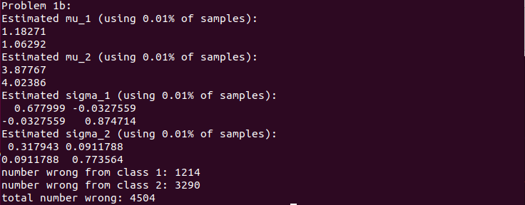

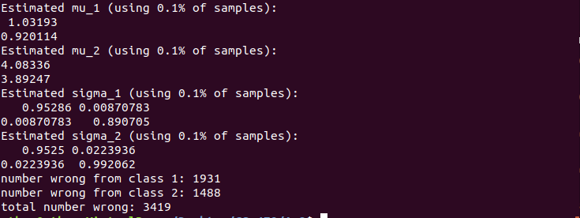

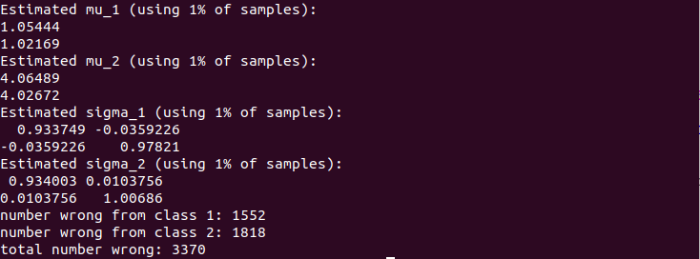

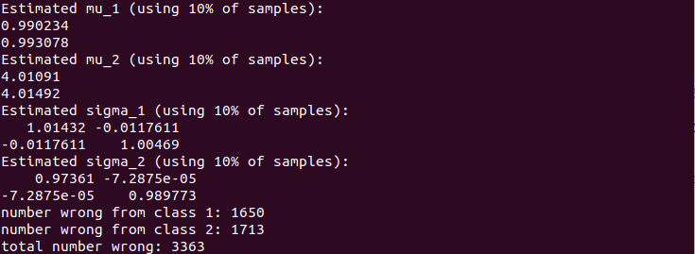

Figure 3 shows the terminal output for part 1.b. As the number of samples used for estimating the distributions increased, the estimated distributions became closer to the expected values, and the number of misclassifications decreased.

2.a

Using the maximum likelihood technique to estimate the distributions for the 200,000 samples from the second distribution from assignment 1, our estimated distributions were similar to the expected values. Once again since the variances of the features were not equal, we used case 3 rather than case 1. The number of misclassifications from assignment 1 was 39244, while the misclassifications from assignment 2 was 10271. This can be seen in the terminal output in figure 4.

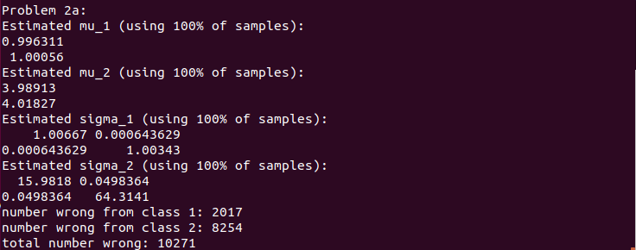

Figure 4 shows the terminal output for part 2.a. Since 100% of the samples were used, the number of misclassifications was relatively low and the estimated distributions were close to the expected values.

2.b

We repeated part 2.a using the same percentages from part 1.b. The trends seen in part 1.b were also present in this case. As the number of samples increased, the estimated distributions were closer and closer to the expected values and the number of misclassifications decreased. The misclassification results can be seen in figure 5, and the estimated distributions can be seen in the terminal output in figure 6.

| Percentage of samples used | Number of total misclassifications |
| --- | --- |
| 0.01% | 10659 |
| 0.1% | 10533 |
| 1% | 10275 |
| 10% | 10261 |
| 100% | 10271 |

Figure 5 shows the number of misclassifications for part 2.b using different percentages of the samples to estimate the distributions. In general, as the number of samples used increases, the number of misclassifications decreases.

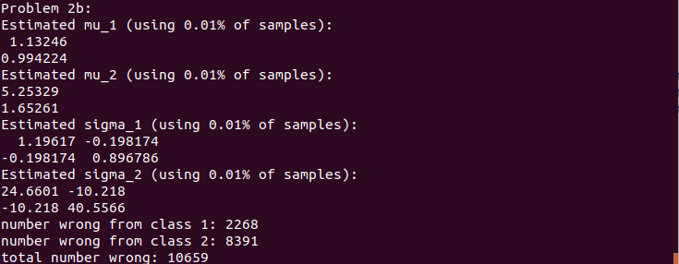

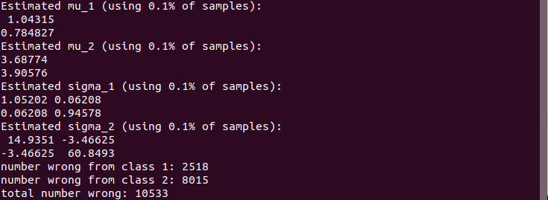

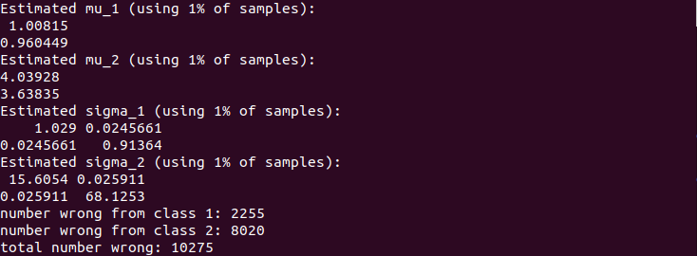

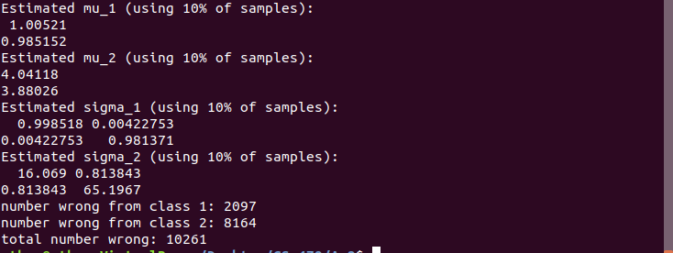

Figure 6 shows the terminal outputs for part 2.b. As the number of samples used to estimate the distributions increased, the distributions got closer and closer to the expected values. In addition, the number of misclassifications decreased as the number of samples increased.

3.a

For this section, we used the reference image alongside the test image to take sample pixel values for skin color. We then used the same methods from parts 1 and 2 to generate estimated means and covariances. Once we had our estimated distributions, we tested each pixel in the test images to classify them as either skin or non-skin using different thresholds. The reference images were then used to count the number of misclassifications. If the reference image showed a black pixel, and the test pixel was classified as skin that would be a false positive. Likewise, if the reference image showed a white or red pixel and the test pixel was classified as non-skin, that would be a false negative. For part 1.a, we used the chromatic color space. The results are given in the ROC curve in figure 8. From the curves it is evident to see that as the number of false positives increase, the number of false negatives decrease. Furthermore, the optimal threshold is given by the point on each curve that is closest to the origin. These optimal thresholds were used to construct the new image with non-skin pixels being set to white. The new images can be seen in figure 7.

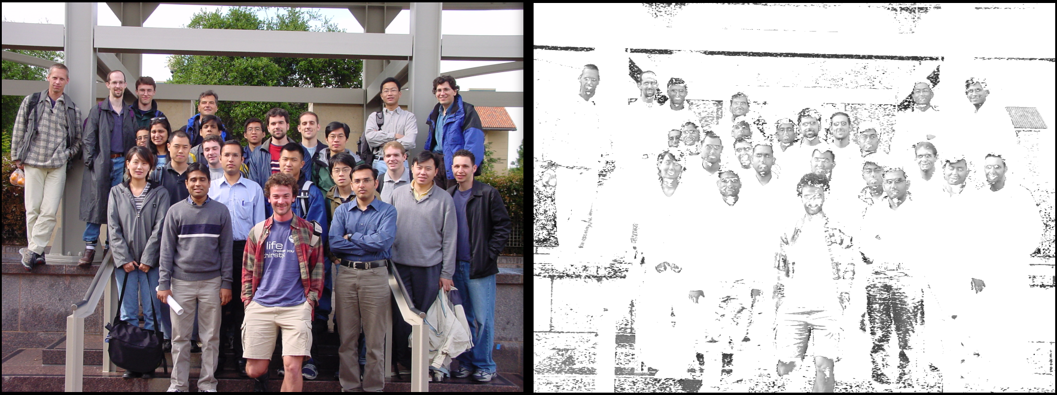

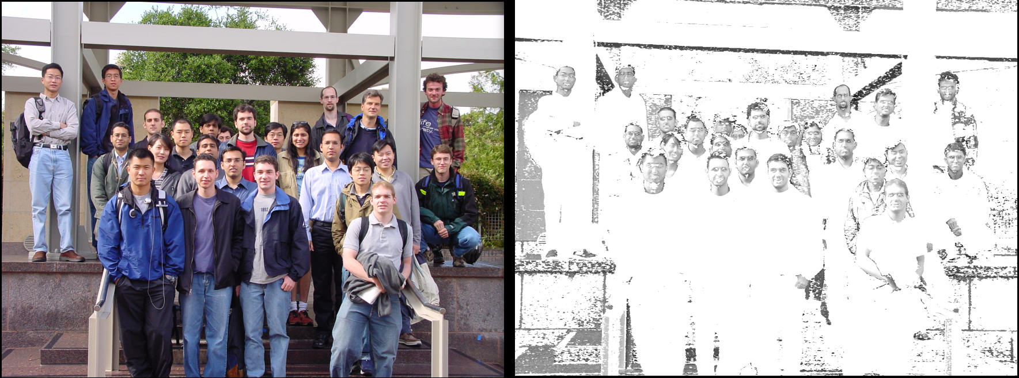

Figure 7 shows the newly generated images using the chromatic space by setting all pixels that were not classified as skin color to white and leaving the pixels that were classified as skin color as their original values.

3.b

Part 3.b is very similar to part 3.a, the only difference being the color space that is used. In part 3.a we used the chromatic color space while in 3.b we used the YCbCr color space. The YCbCr color space led to fewer misclassifications than the chromatic color space. This can be seen in the ROC plots in figure 8 since the YCbCr curves are closer to the origin than the chromatic curves. Additionally, the new images did a better job of distinguishing skin pixels from non-skin pixels as seen in figure 9.

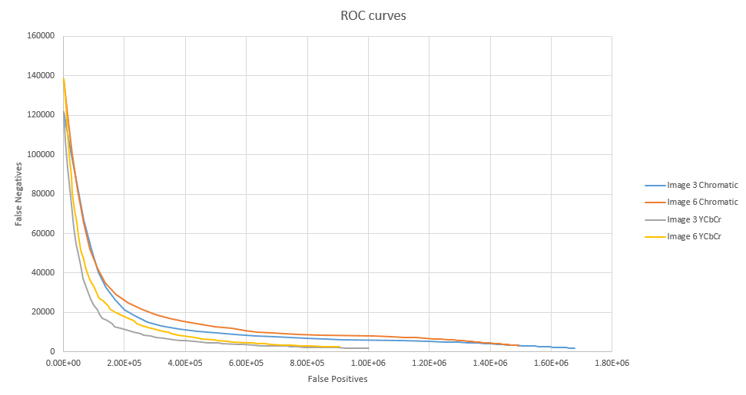

Figure 8 shows the ROC curves for part 3.a and 3.b. From the graph it is evident that the YCbCr color space is better at classifying skin pixels since these curves are closer to the origin than the curves from the chromatic space. It is also clear from the graphs that the number of false positives and the number of false negatives are inversely related. As the number of false positives increases, the number of false negatives decreases.

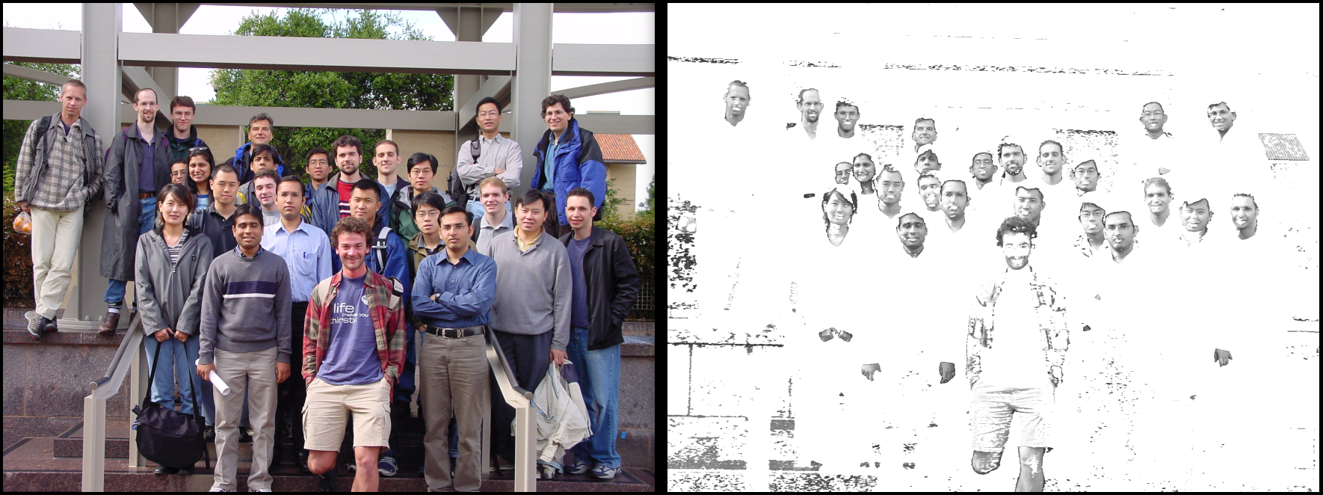

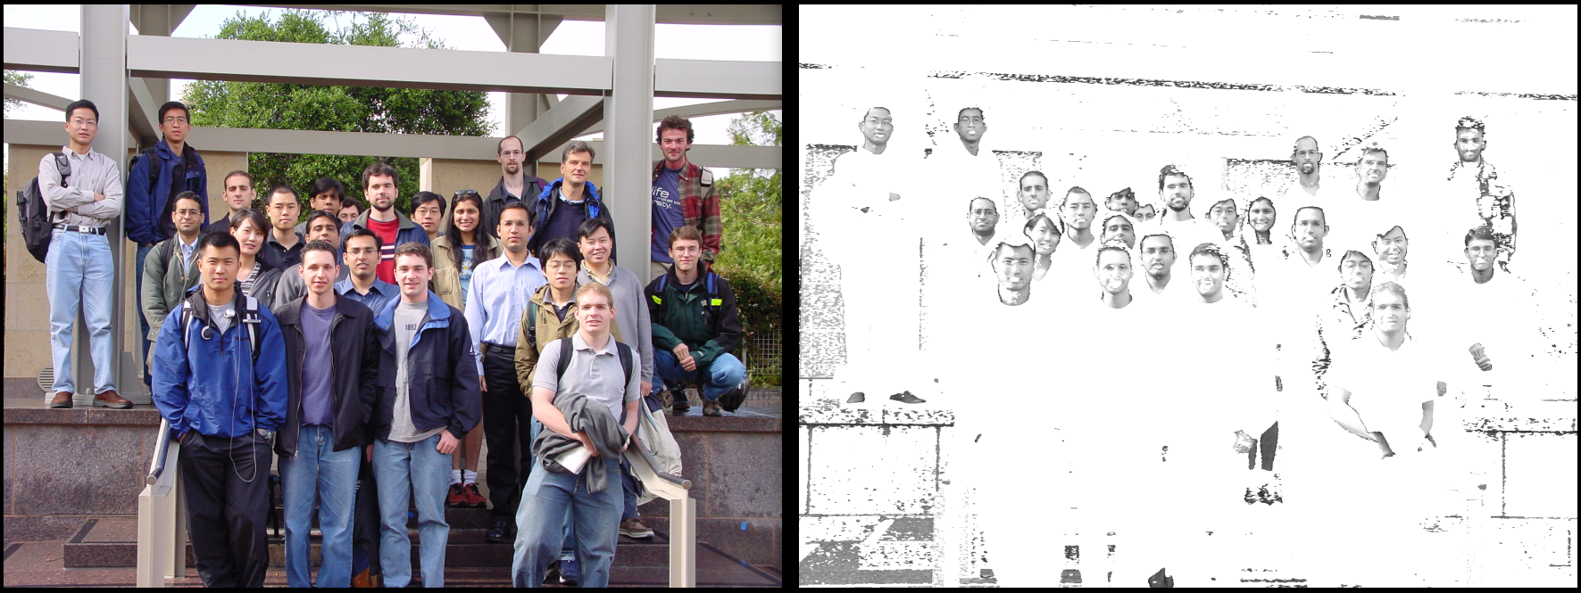

Figure 9 shows the newly generated images using the YCbCr space using the same method as figure 7. The YCbCr color space is better at identifying skin pixels, so new images do a better job of distinguishing between skin and non-skin. This increased performance can also be seen in the ROC curves in figure 8.

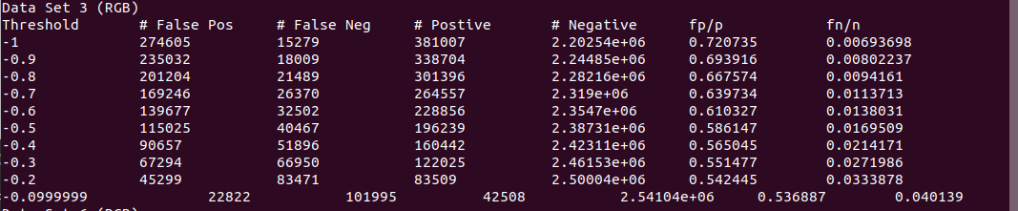

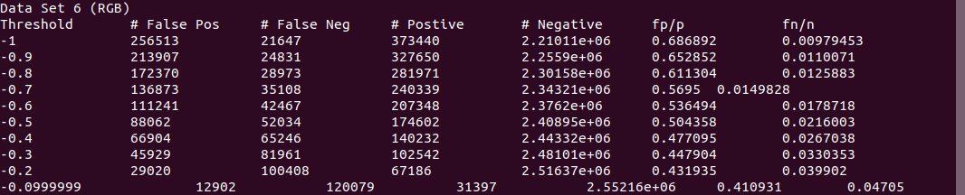

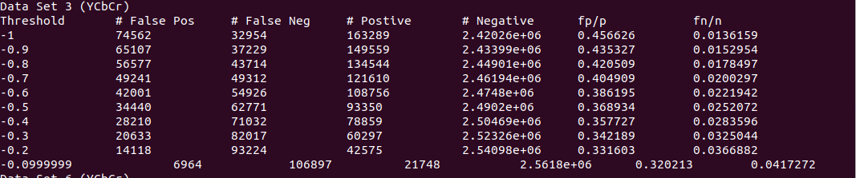

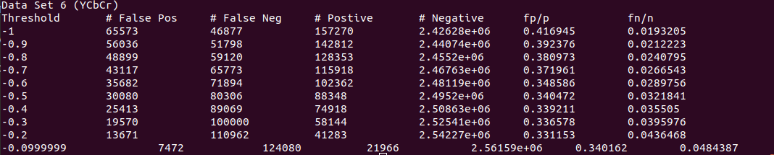

Figure 10 shows the terminal outputs for part 3.a and 3.b. This output gives details regarding the number of each type of misclassification as well as the percentages. These are shortened versions however as each only shows the first 10 sample thresholds while in reality 50 different thresholds were used to generate the ROC curves.

**Source Code**

Problem_1-2.cpp

#include <iostream>

#include "Classifiers.cpp"

#include "boxmuller.cpp"

#include <math.h>

#include <vector>

#include <Eigen/Dense>

using namespace Eigen;

using namespace std;

int main()

{

vector<Vector2f> distribution1;

vector<Vector2f> distribution2;

Vector2f mu_1;

Matrix2f sigma_1;

Vector2f mu_2;

Matrix2f sigma_2;

/*Problem 1*/

// vectors/matricies to hold mu and sigma

mu_1 << 1, 1;

sigma_1 << 1, 0,

0, 1;

mu_2 << 4, 4;

sigma_2 << 1, 0,

0, 1;

// generate the samples

for(int i = 0; i < 100000; i++)

{

distribution1.push_back(Vector2f(box_muller(mu_1(0,0), sigma_1(0,0)), box_muller(mu_1(1,0), sigma_1(1,1))));

}

for(int i = 0; i < 100000; i++)

{

distribution2.push_back(Vector2f(box_muller(mu_2(0,0), sigma_2(0,0)), box_muller(mu_2(1,0), sigma_2(1,1))));

}

cout << "Reference for Problem 1: " << endl;

// array to hold decision made for the classifer

bool p1_reference[200000];

// prior probabilities for reference and 1a

float prior_prob_1 = 0.5;

float prior_prob_2 = 0.5;

// classify the samples using case 1

for (int i = 0, j = 100000; i < 100000; i++, j++)

{

float gi = discriminant_case_1(distribution1[i], mu_1, sigma_1(0,0), prior_prob_1);

float gj = discriminant_case_1(distribution1[i], mu_2, sigma_2(0,0), prior_prob_2);

if (gi - gj > 0)

{

p1_reference[i] = 1;

}

else

{

p1_reference[i] = 0;

}

gi = discriminant_case_1(distribution2[i], mu_1, sigma_1(0,0), prior_prob_1);

gj = discriminant_case_1(distribution2[i], mu_2, sigma_2(0,0), prior_prob_2);

if (gi - gj > 0)

{

p1_reference[j] = 1;

}

else

{

p1_reference[j] = 0;

}

}

// calculate the number of misclassifications made

int wrong1 = 0;

int wrong2 = 0;

for (int i = 0; i < 200000; i++)

{

if (i < 100000)

{

if (p1_reference[i] == 0)

{

wrong1++;

}

}

else

{

if (p1_reference[i] == 1)

{

wrong2++;

}

}

}

cout << "number wrong from class 1: " << wrong1 << endl;

cout << "number wrong from class 2: " << wrong2 << endl;

cout << "total number wrong: " << wrong1 + wrong2 << endl;

cout << "Problem 1a: " << endl;

// find estimated sample means

Vector2f estimated_mu_1 = ml_mean(distribution1, 100000);

Vector2f estimated_mu_2 = ml_mean(distribution2, 100000);

// find estimated sample covariances

Matrix2f estimated_sigma_1 = ml_covariance(distribution1, estimated_mu_1, 100000);

Matrix2f estimated_sigma_2 = ml_covariance(distribution2, estimated_mu_2, 100000);

cout << "Estimated mu_1 (using 100% of samples):" << endl;

cout << estimated_mu_1 << endl;

cout << "Estimated mu_2 (using 100% of samples):" << endl;

cout << estimated_mu_2 << endl;

cout << "Estimated sigma_1 (using 100% of samples):" << endl;

cout << estimated_sigma_1 << endl;

cout << "Estimated sigma_2 (using 100% of samples):" << endl;

cout << estimated_sigma_2 << endl;

bool p1_a_decision[200000];

// classify the samples using case 3

for (int i = 0, j = 100000; i < 100000; i++, j++)

{

float gi = discriminant_case_3(distribution1[i], estimated_mu_1, estimated_sigma_1, prior_prob_1);

float gj = discriminant_case_3(distribution1[i], estimated_mu_2, estimated_sigma_2, prior_prob_2);

if (gi - gj > 0)

{

p1_a_decision[i] = 1;

}

else

{

p1_a_decision[i] = 0;

}

gi = discriminant_case_3(distribution2[i], estimated_mu_1, estimated_sigma_1, prior_prob_1);

gj = discriminant_case_3(distribution2[i], estimated_mu_2, estimated_sigma_2, prior_prob_2);

if (gi - gj > 0)

{

p1_a_decision[j] = 1;

}

else

{

p1_a_decision[j] = 0;

}

}

wrong1 = 0;

wrong2 = 0;

for (int i = 0; i < 200000; i++)

{

if (i < 100000)

{

if (p1_a_decision[i] == 0)

{

wrong1++;

}

}

else

{

if (p1_a_decision[i] == 1)

{

wrong2++;

}

}

}

cout << "number wrong from class 1: " << wrong1 << endl;

cout << "number wrong from class 2: " << wrong2 << endl;

cout << "total number wrong: " << wrong1 + wrong2 << endl;

cout << "Problem 1b: " << endl;

//shuffle distribution

random_shuffle(distribution1.begin(), distribution1.end());

// find estimated sample means using 0.01% of samples

estimated_mu_1 = ml_mean(distribution1, 10);

estimated_mu_2 = ml_mean(distribution2, 10);

// find estimated sample covariances using 0.01% of samples

estimated_sigma_1 = ml_covariance(distribution1, estimated_mu_1, 10);

estimated_sigma_2 = ml_covariance(distribution2, estimated_mu_2, 10);

cout << "Estimated mu_1 (using 0.01% of samples):" << endl;

cout << estimated_mu_1 << endl;

cout << "Estimated mu_2 (using 0.01% of samples):" << endl;

cout << estimated_mu_2 << endl;

cout << "Estimated sigma_1 (using 0.01% of samples):" << endl;

cout << estimated_sigma_1 << endl;

cout << "Estimated sigma_2 (using 0.01% of samples):" << endl;

cout << estimated_sigma_2 << endl;

bool p1_b_decision_1[200000];

// classify the samples using case 3

for (int i = 0, j = 100000; i < 100000; i++, j++)

{

float gi = discriminant_case_3(distribution1[i], estimated_mu_1, estimated_sigma_1, prior_prob_1);

float gj = discriminant_case_3(distribution1[i], estimated_mu_2, estimated_sigma_2, prior_prob_2);

if (gi - gj > 0)

{

p1_b_decision_1[i] = 1;

}

else

{

p1_b_decision_1[i] = 0;

}

gi = discriminant_case_3(distribution2[i], estimated_mu_1, estimated_sigma_1, prior_prob_1);

gj = discriminant_case_3(distribution2[i], estimated_mu_2, estimated_sigma_2, prior_prob_2);

if (gi - gj > 0)

{

p1_b_decision_1[j] = 1;

}

else

{

p1_b_decision_1[j] = 0;

}

}

wrong1 = 0;

wrong2 = 0;

for (int i = 0; i < 200000; i++)

{

if (i < 100000)

{

if (p1_b_decision_1[i] == 0)

{

wrong1++;

}

}

else

{

if (p1_b_decision_1[i] == 1)

{

wrong2++;

}

}

}

cout << "number wrong from class 1: " << wrong1 << endl;

cout << "number wrong from class 2: " << wrong2 << endl;

cout << "total number wrong: " << wrong1 + wrong2 << endl;

// find estimated sample means using 0.1% of samples

estimated_mu_1 = ml_mean(distribution1, 100);

estimated_mu_2 = ml_mean(distribution2, 100);

// find estimated sample covariances using 0.1% of samples

estimated_sigma_1 = ml_covariance(distribution1, estimated_mu_1, 100);

estimated_sigma_2 = ml_covariance(distribution2, estimated_mu_2, 100);

cout << "Estimated mu_1 (using 0.1% of samples):" << endl;

cout << estimated_mu_1 << endl;

cout << "Estimated mu_2 (using 0.1% of samples):" << endl;

cout << estimated_mu_2 << endl;

cout << "Estimated sigma_1 (using 0.1% of samples):" << endl;

cout << estimated_sigma_1 << endl;

cout << "Estimated sigma_2 (using 0.1% of samples):" << endl;

cout << estimated_sigma_2 << endl;

bool p1_b_decision_2[200000];

// classify the samples using case 3

for (int i = 0, j = 100000; i < 100000; i++, j++)

{

float gi = discriminant_case_3(distribution1[i], estimated_mu_1, estimated_sigma_1, prior_prob_1);

float gj = discriminant_case_3(distribution1[i], estimated_mu_2, estimated_sigma_2, prior_prob_2);

if (gi - gj > 0)

{

p1_b_decision_2[i] = 1;

}

else

{

p1_b_decision_2[i] = 0;

}

gi = discriminant_case_3(distribution2[i], estimated_mu_1, estimated_sigma_1, prior_prob_1);

gj = discriminant_case_3(distribution2[i], estimated_mu_2, estimated_sigma_2, prior_prob_2);

if (gi - gj > 0)

{

p1_b_decision_2[j] = 1;

}

else

{

p1_b_decision_2[j] = 0;

}

}

wrong1 = 0;

wrong2 = 0;

for (int i = 0; i < 200000; i++)

{

if (i < 100000)

{

if (p1_b_decision_2[i] == 0)

{

wrong1++;

}

}

else

{

if (p1_b_decision_2[i] == 1)

{

wrong2++;

}

}

}

cout << "number wrong from class 1: " << wrong1 << endl;

cout << "number wrong from class 2: " << wrong2 << endl;

cout << "total number wrong: " << wrong1 + wrong2 << endl;

// find estimated sample means using 1% of samples

estimated_mu_1 = ml_mean(distribution1, 1000);

estimated_mu_2 = ml_mean(distribution2, 1000);

// find estimated sample covariances using 1% of samples

estimated_sigma_1 = ml_covariance(distribution1, estimated_mu_1, 1000);

estimated_sigma_2 = ml_covariance(distribution2, estimated_mu_2, 1000);

cout << "Estimated mu_1 (using 1% of samples):" << endl;

cout << estimated_mu_1 << endl;

cout << "Estimated mu_2 (using 1% of samples):" << endl;

cout << estimated_mu_2 << endl;

cout << "Estimated sigma_1 (using 1% of samples):" << endl;

cout << estimated_sigma_1 << endl;

cout << "Estimated sigma_2 (using 1% of samples):" << endl;

cout << estimated_sigma_2 << endl;

bool p1_b_decision_3[200000];

// classify the samples using case 3

for (int i = 0, j = 100000; i < 100000; i++, j++)

{

float gi = discriminant_case_3(distribution1[i], estimated_mu_1, estimated_sigma_1, prior_prob_1);

float gj = discriminant_case_3(distribution1[i], estimated_mu_2, estimated_sigma_2, prior_prob_2);

if (gi - gj > 0)

{

p1_b_decision_3[i] = 1;

}

else

{

p1_b_decision_3[i] = 0;

}

gi = discriminant_case_3(distribution2[i], estimated_mu_1, estimated_sigma_1, prior_prob_1);

gj = discriminant_case_3(distribution2[i], estimated_mu_2, estimated_sigma_2, prior_prob_2);

if (gi - gj > 0)

{

p1_b_decision_3[j] = 1;

}

else

{

p1_b_decision_3[j] = 0;

}

}

wrong1 = 0;

wrong2 = 0;

for (int i = 0; i < 200000; i++)

{

if (i < 100000)

{

if (p1_b_decision_3[i] == 0)

{

wrong1++;

}

}

else

{

if (p1_b_decision_3[i] == 1)

{

wrong2++;

}

}

}

cout << "number wrong from class 1: " << wrong1 << endl;

cout << "number wrong from class 2: " << wrong2 << endl;

cout << "total number wrong: " << wrong1 + wrong2 << endl;

// find estimated sample means using 10% of samples

estimated_mu_1 = ml_mean(distribution1, 10000);

estimated_mu_2 = ml_mean(distribution2, 10000);

// find estimated sample covariances using 10% of samples

estimated_sigma_1 = ml_covariance(distribution1, estimated_mu_1, 10000);

estimated_sigma_2 = ml_covariance(distribution2, estimated_mu_2, 10000);

cout << "Estimated mu_1 (using 10% of samples):" << endl;

cout << estimated_mu_1 << endl;

cout << "Estimated mu_2 (using 10% of samples):" << endl;

cout << estimated_mu_2 << endl;

cout << "Estimated sigma_1 (using 10% of samples):" << endl;

cout << estimated_sigma_1 << endl;

cout << "Estimated sigma_2 (using 10% of samples):" << endl;

cout << estimated_sigma_2 << endl;

bool p1_b_decision_4[200000];

// classify the samples using case 3

for (int i = 0, j = 100000; i < 100000; i++, j++)

{

float gi = discriminant_case_3(distribution1[i], estimated_mu_1, estimated_sigma_1, prior_prob_1);

float gj = discriminant_case_3(distribution1[i], estimated_mu_2, estimated_sigma_2, prior_prob_2);

if (gi - gj > 0)

{

p1_b_decision_4[i] = 1;

}

else

{

p1_b_decision_4[i] = 0;

}

gi = discriminant_case_3(distribution2[i], estimated_mu_1, estimated_sigma_1, prior_prob_1);

gj = discriminant_case_3(distribution2[i], estimated_mu_2, estimated_sigma_2, prior_prob_2);

if (gi - gj > 0)

{

p1_b_decision_4[j] = 1;

}

else

{

p1_b_decision_4[j] = 0;

}

}

wrong1 = 0;

wrong2 = 0;

for (int i = 0; i < 200000; i++)

{

if (i < 100000)

{

if (p1_b_decision_4[i] == 0)

{

wrong1++;

}

}

else

{

if (p1_b_decision_4[i] == 1)

{

wrong2++;

}

}

}

cout << "number wrong from class 1: " << wrong1 << endl;

cout << "number wrong from class 2: " << wrong2 << endl;

cout << "total number wrong: " << wrong1 + wrong2 << endl;

/*Problem 2*/

// vectors/matricies to hold mu and sigma

mu_1 << 1, 1;

sigma_1 << 1, 0,

0, 1;

mu_2 << 4, 4;

sigma_2 << 4, 0,

0, 8;

distribution1.clear();

distribution2.clear();

// generate the samples

for(int i = 0; i < 100000; i++)

{

distribution1.push_back(Vector2f(box_muller(mu_1(0,0), sigma_1(0,0)), box_muller(mu_1(1,0), sigma_1(1,1))));

}

for(int i = 0; i < 100000; i++)

{

distribution2.push_back(Vector2f(box_muller(mu_2(0,0), sigma_2(0,0)), box_muller(mu_2(1,0), sigma_2(1,1))));

}

cout << "Problem 2a: " << endl;

// find estimated sample means using 100% of samples

estimated_mu_1 = ml_mean(distribution1, 100000);

estimated_mu_2 = ml_mean(distribution2, 100000);

// find estimated sample covariances using 100% of samples

estimated_sigma_1 = ml_covariance(distribution1, estimated_mu_1, 100000);

estimated_sigma_2 = ml_covariance(distribution2, estimated_mu_2, 100000);

cout << "Estimated mu_1 (using 100% of samples):" << endl;

cout << estimated_mu_1 << endl;

cout << "Estimated mu_2 (using 100% of samples):" << endl;

cout << estimated_mu_2 << endl;

cout << "Estimated sigma_1 (using 100% of samples):" << endl;

cout << estimated_sigma_1 << endl;

cout << "Estimated sigma_2 (using 100% of samples):" << endl;

cout << estimated_sigma_2 << endl;

bool p2_a_decision[200000];

// classify the samples using case 3

for (int i = 0, j = 100000; i < 100000; i++, j++)

{

float gi = discriminant_case_3(distribution1[i], estimated_mu_1, estimated_sigma_1, prior_prob_1);

float gj = discriminant_case_3(distribution1[i], estimated_mu_2, estimated_sigma_2, prior_prob_2);

if (gi - gj > 0)

{

p2_a_decision[i] = 1;

}

else

{

p2_a_decision[i] = 0;

}

gi = discriminant_case_3(distribution2[i], estimated_mu_1, estimated_sigma_1, prior_prob_1);

gj = discriminant_case_3(distribution2[i], estimated_mu_2, estimated_sigma_2, prior_prob_2);

if (gi - gj > 0)

{

p2_a_decision[j] = 1;

}

else

{

p2_a_decision[j] = 0;

}

}

wrong1 = 0;

wrong2 = 0;

for (int i = 0; i < 200000; i++)

{

if (i < 100000)

{

if (p2_a_decision[i] == 0)

{

wrong1++;

}

}

else

{

if (p2_a_decision[i] == 1)

{

wrong2++;

}

}

}

cout << "number wrong from class 1: " << wrong1 << endl;

cout << "number wrong from class 2: " << wrong2 << endl;

cout << "total number wrong: " << wrong1 + wrong2 << endl;

cout << "Problem 2b: " << endl;

// shuffle distribution

random_shuffle(distribution1.begin(), distribution1.end());

// find estimated sample means using 0.01% of samples

estimated_mu_1 = ml_mean(distribution1, 10);

estimated_mu_2 = ml_mean(distribution2, 10);

// find estimated sample covariances using 0.01% of samples

estimated_sigma_1 = ml_covariance(distribution1, estimated_mu_1, 10);

estimated_sigma_2 = ml_covariance(distribution2, estimated_mu_2, 10);

cout << "Estimated mu_1 (using 0.01% of samples):" << endl;

cout << estimated_mu_1 << endl;

cout << "Estimated mu_2 (using 0.01% of samples):" << endl;

cout << estimated_mu_2 << endl;

cout << "Estimated sigma_1 (using 0.01% of samples):" << endl;

cout << estimated_sigma_1 << endl;

cout << "Estimated sigma_2 (using 0.01% of samples):" << endl;

cout << estimated_sigma_2 << endl;

bool p2_b_decision_1[200000];

// classify the samples using case 3

for (int i = 0, j = 100000; i < 100000; i++, j++)

{

float gi = discriminant_case_3(distribution1[i], estimated_mu_1, estimated_sigma_1, prior_prob_1);

float gj = discriminant_case_3(distribution1[i], estimated_mu_2, estimated_sigma_2, prior_prob_2);

if (gi - gj > 0)

{

p2_b_decision_1[i] = 1;

}

else

{

p2_b_decision_1[i] = 0;

}

gi = discriminant_case_3(distribution2[i], estimated_mu_1, estimated_sigma_1, prior_prob_1);

gj = discriminant_case_3(distribution2[i], estimated_mu_2, estimated_sigma_2, prior_prob_2);

if (gi - gj > 0)

{

p2_b_decision_1[j] = 1;

}

else

{

p2_b_decision_1[j] = 0;

}

}

wrong1 = 0;

wrong2 = 0;

for (int i = 0; i < 200000; i++)

{

if (i < 100000)

{

if (p2_b_decision_1[i] == 0)

{

wrong1++;

}

}

else

{

if (p2_b_decision_1[i] == 1)

{

wrong2++;

}

}

}

cout << "number wrong from class 1: " << wrong1 << endl;

cout << "number wrong from class 2: " << wrong2 << endl;

cout << "total number wrong: " << wrong1 + wrong2 << endl;

// find estimated sample means using 0.1% of samples

estimated_mu_1 = ml_mean(distribution1, 100);

estimated_mu_2 = ml_mean(distribution2, 100);

// find estimated sample covariances using 0.1% of samples

estimated_sigma_1 = ml_covariance(distribution1, estimated_mu_1, 100);

estimated_sigma_2 = ml_covariance(distribution2, estimated_mu_2, 100);

cout << "Estimated mu_1 (using 0.1% of samples):" << endl;

cout << estimated_mu_1 << endl;

cout << "Estimated mu_2 (using 0.1% of samples):" << endl;

cout << estimated_mu_2 << endl;

cout << "Estimated sigma_1 (using 0.1% of samples):" << endl;

cout << estimated_sigma_1 << endl;

cout << "Estimated sigma_2 (using 0.1% of samples):" << endl;

cout << estimated_sigma_2 << endl;

bool p2_b_decision_2[200000];

// classify the samples using case 3

for (int i = 0, j = 100000; i < 100000; i++, j++)

{

float gi = discriminant_case_3(distribution1[i], estimated_mu_1, estimated_sigma_1, prior_prob_1);

float gj = discriminant_case_3(distribution1[i], estimated_mu_2, estimated_sigma_2, prior_prob_2);

if (gi - gj > 0)

{

p2_b_decision_2[i] = 1;

}

else

{

p2_b_decision_2[i] = 0;

}

gi = discriminant_case_3(distribution2[i], estimated_mu_1, estimated_sigma_1, prior_prob_1);

gj = discriminant_case_3(distribution2[i], estimated_mu_2, estimated_sigma_2, prior_prob_2);

if (gi - gj > 0)

{

p2_b_decision_2[j] = 1;

}

else

{

p2_b_decision_2[j] = 0;

}

}

wrong1 = 0;

wrong2 = 0;

for (int i = 0; i < 200000; i++)

{

if (i < 100000)

{

if (p2_b_decision_2[i] == 0)

{

wrong1++;

}

}

else

{

if (p2_b_decision_2[i] == 1)

{

wrong2++;

}

}

}

cout << "number wrong from class 1: " << wrong1 << endl;

cout << "number wrong from class 2: " << wrong2 << endl;

cout << "total number wrong: " << wrong1 + wrong2 << endl;

// find estimated sample means using 1% of samples

estimated_mu_1 = ml_mean(distribution1, 1000);

estimated_mu_2 = ml_mean(distribution2, 1000);

// find estimated sample covariances using 1% of samples

estimated_sigma_1 = ml_covariance(distribution1, estimated_mu_1, 1000);

estimated_sigma_2 = ml_covariance(distribution2, estimated_mu_2, 1000);

cout << "Estimated mu_1 (using 1% of samples):" << endl;

cout << estimated_mu_1 << endl;

cout << "Estimated mu_2 (using 1% of samples):" << endl;

cout << estimated_mu_2 << endl;

cout << "Estimated sigma_1 (using 1% of samples):" << endl;

cout << estimated_sigma_1 << endl;

cout << "Estimated sigma_2 (using 1% of samples):" << endl;

cout << estimated_sigma_2 << endl;

bool p2_b_decision_3[200000];

// classify the samples using case 3

for (int i = 0, j = 100000; i < 100000; i++, j++)

{

float gi = discriminant_case_3(distribution1[i], estimated_mu_1, estimated_sigma_1, prior_prob_1);

float gj = discriminant_case_3(distribution1[i], estimated_mu_2, estimated_sigma_2, prior_prob_2);

if (gi - gj > 0)

{

p2_b_decision_3[i] = 1;

}

else

{

p2_b_decision_3[i] = 0;

}

gi = discriminant_case_3(distribution2[i], estimated_mu_1, estimated_sigma_1, prior_prob_1);

gj = discriminant_case_3(distribution2[i], estimated_mu_2, estimated_sigma_2, prior_prob_2);

if (gi - gj > 0)

{

p2_b_decision_3[j] = 1;

}

else

{

p2_b_decision_3[j] = 0;

}

}

wrong1 = 0;

wrong2 = 0;

for (int i = 0; i < 200000; i++)

{

if (i < 100000)

{

if (p2_b_decision_3[i] == 0)

{

wrong1++;

}

}

else

{

if (p2_b_decision_3[i] == 1)

{

wrong2++;

}

}

}

cout << "number wrong from class 1: " << wrong1 << endl;

cout << "number wrong from class 2: " << wrong2 << endl;

cout << "total number wrong: " << wrong1 + wrong2 << endl;

// find estimated sample means using 10% of samples

estimated_mu_1 = ml_mean(distribution1, 10000);

estimated_mu_2 = ml_mean(distribution2, 10000);

// find estimated sample covariances using 10% of samples

estimated_sigma_1 = ml_covariance(distribution1, estimated_mu_1, 10000);

estimated_sigma_2 = ml_covariance(distribution2, estimated_mu_2, 10000);

cout << "Estimated mu_1 (using 10% of samples):" << endl;

cout << estimated_mu_1 << endl;

cout << "Estimated mu_2 (using 10% of samples):" << endl;

cout << estimated_mu_2 << endl;

cout << "Estimated sigma_1 (using 10% of samples):" << endl;

cout << estimated_sigma_1 << endl;

cout << "Estimated sigma_2 (using 10% of samples):" << endl;

cout << estimated_sigma_2 << endl;

bool p2_b_decision_4[200000];

// classify the samples using case 3

for (int i = 0, j = 100000; i < 100000; i++, j++)

{

float gi = discriminant_case_3(distribution1[i], estimated_mu_1, estimated_sigma_1, prior_prob_1);

float gj = discriminant_case_3(distribution1[i], estimated_mu_2, estimated_sigma_2, prior_prob_2);

if (gi - gj > 0)

{

p2_b_decision_4[i] = 1;

}

else

{

p2_b_decision_4[i] = 0;

}

gi = discriminant_case_3(distribution2[i], estimated_mu_1, estimated_sigma_1, prior_prob_1);

gj = discriminant_case_3(distribution2[i], estimated_mu_2, estimated_sigma_2, prior_prob_2);

if (gi - gj > 0)

{

p2_b_decision_4[j] = 1;

}

else

{

p2_b_decision_4[j] = 0;

}

}

wrong1 = 0;

wrong2 = 0;

for (int i = 0; i < 200000; i++)

{

if (i < 100000)

{

if (p2_b_decision_4[i] == 0)

{

wrong1++;

}

}

else

{

if (p2_b_decision_4[i] == 1)

{

wrong2++;

}

}

}

cout << "number wrong from class 1: " << wrong1 << endl;

cout << "number wrong from class 2: " << wrong2 << endl;

cout << "total number wrong: " << wrong1 + wrong2 << endl;

}

Problem_3.cpp

#include <iostream>

#include <fstream>

#include "ReadImage.cpp"

#include "WriteImage.cpp"

#include "ReadImageHeader.cpp"

#include "image.h"

#include "image.cpp"

#include <bits/stdc++.h>

#include "Classifiers.cpp"

#include <math.h>

#include <vector>

#include <Eigen/Dense>

using namespace Eigen;

int main()

{

RGB val;

// image variables

int T_1_M, T_1_N, T_1_Q;

bool T_1_type;

int R_1_M, R_1_N, R_1_Q;

bool R_1_type;

ofstream output;

// read training image

string s = "Data/Training_1.ppm";

int string_size = s.length();

char training1_string[string_size];

strcpy(training1_string, s.c_str());

readImageHeader(training1_string, T_1_N, T_1_M, T_1_Q, T_1_type);

ImageType training1(T_1_N, T_1_M, T_1_Q);

readImage(training1_string, training1);

// read reference image

s = "Data/ref1.ppm";

string_size = s.length();

char ref1_string[string_size];

strcpy(ref1_string, s.c_str());

readImageHeader(ref1_string, R_1_N, R_1_M, R_1_Q, R_1_type);

ImageType ref1(R_1_N, R_1_M, R_1_Q);

readImage(ref1_string, ref1);

// vectors to store the sample data

vector<Vector2f> skin_sample_data;

vector<Vector2f> not_skin_sample_data;

/***Problem 3 A***/

cout << "Problem 3A:" << endl;

// variables to stor estimated means and covariances for nomalized RGB values

Vector2f skin_estimated_mu_RGB;

Matrix2f skin_estimated_sigma_RGB;

Vector2f not_skin_estimated_mu_RGB;

Matrix2f not_skin_estimated_sigma_RGB;

float total=0;

float x1=0;

float x2=0;

// generate the skin and non-skin samples from first data set us normalized RGB values

for(int i=0; i<T_1_N; i++)

{

for(int j=0; j<T_1_M; j++)

{

training1.getPixelVal(i, j, val);

total = val.r + val.g + val.b;

if(total == 0)

{

x1 = 0;

x2 = 0;

}

else

{

x1 = (float)val.r / total;

x2 = (float)val.g / total;

}

ref1.getPixelVal(i, j, val);

if(val.r != 0 && val.g != 0 && val.b != 0)

{

skin_sample_data.push_back(Vector2f(x1, x2));

}

else

{

not_skin_sample_data.push_back(Vector2f(x1, x2));

}

}

}

// calculate estimated means and covariances

skin_estimated_mu_RGB = ml_mean(skin_sample_data, skin_sample_data.size());

skin_estimated_sigma_RGB = ml_covariance(skin_sample_data, skin_estimated_mu_RGB, skin_sample_data.size());

not_skin_estimated_mu_RGB = ml_mean(not_skin_sample_data, not_skin_sample_data.size());

not_skin_estimated_sigma_RGB = ml_covariance(not_skin_sample_data, not_skin_estimated_mu_RGB, not_skin_sample_data.size());

/**Data Set 3 RGB**/

cout << "Data Set 3 (RGB)" << endl;

// image variables

int T_3_M, T_3_N, T_3_Q;

bool T_3_type;

int R_3_M, R_3_N, R_3_Q;

bool R_3_type;

// read training image

s = "Data/Training_3.ppm";

string_size = s.length();

char training3_string[string_size];

strcpy(training3_string, s.c_str());

readImageHeader(training3_string, T_3_N, T_3_M, T_3_Q, T_3_type);

ImageType training3(T_3_N, T_3_M, T_3_Q);

readImage(training3_string, training3);

// read reference image

s = "Data/ref3.ppm";

string_size = s.length();

char ref3_string[string_size];

strcpy(ref3_string, s.c_str());

readImageHeader(ref3_string, R_3_N, R_3_M, R_3_Q, R_3_type);

ImageType ref3(R_3_N, R_3_M, R_3_Q);

readImage(ref3_string, ref3);

// variables to store the number of negatives, positives, false negatives, and false positives

vector<float> falseNegatives, falsePositives;

float negative, positive, false_negative, false_positive;

total = 0;

/**Find ROC plot points**/

cout << "Threshold" << "\t" << "# False Pos" << "\t"

<< "# False Neg" << "\t" << "# Postive" << "\t" << "# Negative"

<< "\t" << "fp/p" << "\t" << "\t" << "fn/n" << endl;

for(float threshold = -5; threshold <= 0.00; threshold+=0.1)

{

negative = 0;

positive = 0;

false_negative = 0;

false_positive = 0;

for(int i=0; i<T_3_N; i++)

{

for(int j=0; j<T_3_M; j++)

{

training3.getPixelVal(i, j, val);

total = val.r + val.g + val.b;

x1 = (float)val.r / total;

x2 = (float)val.g / total;

bool skin = threshold_case_3(Vector2f(x1, x2), skin_estimated_mu_RGB, skin_estimated_sigma_RGB, threshold);

ref3.getPixelVal(i, j, val);

if(skin)

{

positive++;

}

else

{

negative++;

}

if((val.r != 0 && val.g != 0 && val.b != 0) && !skin)

{

false_negative++;

}

else if(!(val.r != 0 && val.g != 0 && val.b != 0) && skin)

{

false_positive++;

}

}

}

falseNegatives.push_back(false_negative);

falsePositives.push_back(false_positive);

cout << threshold << "\t" << "\t" << false_positive << "\t" << "\t" <<

false_negative << "\t" << "\t" << positive << "\t" << "\t" << negative <<

"\t" << false_positive/positive << "\t" << false_negative/negative << endl;

}

// log thresholds, false positives, and false negatives to output files

output.open("Output/P3_a_data3_thresh.txt");

for(float threshold = -5; threshold <= 0.01; threshold+=0.1)

{

output << threshold << endl;

}

output.close();

output.open("Output/P3_a_data3_false_neg.txt");

for(float threshold = -5, i = 0; threshold <= 0.01; threshold+=0.1, i++)

{

output << falseNegatives[i] << endl;

}

output.close();

output.open("Output/P3_a_data3_false_pos.txt");

for(float threshold = -5, i = 0; threshold <= 0.01; threshold+=0.1, i++)

{

output << falsePositives[i] << endl;

}

output.close();

/**Create New Image**/

// optimal threshold found via ROC plot

total = 0;

ImageType a3_output_image(T_3_N, T_3_M, T_3_Q);

for(int i=0; i<T_3_N; i++)

{

for(int j=0; j<T_3_M; j++)

{

training3.getPixelVal(i, j, val);

total = val.r + val.g + val.b;

x1 = (float)val.r / total;

x2 = (float)val.g / total;

bool skin = threshold_case_3(Vector2f(x1, x2), skin_estimated_mu_RGB, skin_estimated_sigma_RGB, -0.9);

if(skin)

{

a3_output_image.setPixelVal(i, j, RGB(val.r, val.g, val.b));

}

else

{

a3_output_image.setPixelVal(i, j, RGB(255, 255, 255));

}

}

}

// write image

s = "Output/P3_a_image3_ouput.ppm";

string_size = s.length();

char a3_output[string_size];

strcpy(a3_output, s.c_str());

writeImage(a3_output, a3_output_image);

/**Data Set 6 RGB**/

cout << "Data Set 6 (RGB)" << endl;

// image variables

int T_6_M, T_6_N, T_6_Q;

bool T_6_type;

int R_6_M, R_6_N, R_6_Q;

bool R_6_type;

// read training image

s = "Data/Training_6.ppm";

string_size = s.length();

char training6_string[string_size];

strcpy(training6_string, s.c_str());

readImageHeader(training6_string, T_6_N, T_6_M, T_6_Q, T_6_type);

ImageType training6(T_6_N, T_6_M, T_6_Q);

readImage(training6_string, training6);

// read reference image

s = "Data/ref6.ppm";

string_size = s.length();

char ref6_string[string_size];

strcpy(ref6_string, s.c_str());

readImageHeader(ref6_string, R_6_N, R_6_M, R_6_Q, R_6_type);

ImageType ref6(R_6_N, R_6_M, R_6_Q);

readImage(ref6_string, ref6);

falseNegatives.clear();

falsePositives.clear();

total = 0;

/**Find ROC plot points**/

cout << "Threshold" << "\t" << "# False Pos" << "\t"

<< "# False Neg" << "\t" << "# Postive" << "\t" << "# Negative"

<< "\t" << "fp/p" << "\t" << "\t" << "fn/n" << endl;

for(float threshold = -5; threshold <= 0.00; threshold+=0.1)

{

negative = 0;

positive = 0;

false_negative = 0;

false_positive = 0;

for(int i=0; i<T_6_N; i++)

{

for(int j=0; j<T_6_M; j++)

{

training6.getPixelVal(i, j, val);

total = val.r + val.g + val.b;

x1 = (float)val.r / total;

x2 = (float)val.g / total;

bool skin = threshold_case_3(Vector2f(x1, x2), skin_estimated_mu_RGB, skin_estimated_sigma_RGB, threshold);

ref6.getPixelVal(i, j, val);

if(skin)

{

positive++;

}

else

{

negative++;

}

if((val.r != 0 && val.g != 0 && val.b != 0) && !skin)

{

false_negative++;

}

else if(!(val.r != 0 && val.g != 0 && val.b != 0) && skin)

{

false_positive++;

}

}

}

falseNegatives.push_back(false_negative);

falsePositives.push_back(false_positive);

cout << threshold << "\t" << "\t" << false_positive << "\t" << "\t" <<

false_negative << "\t" << "\t" << positive << "\t" << "\t" << negative <<

"\t" << false_positive/positive << "\t" << false_negative/negative << endl;

}

// log thresholds, false positives, and false negatives to output files

output.open("Output/P3_a_data6_thresh.txt");

for(float threshold = -5; threshold <= 0.01; threshold+=0.1)

{

output << threshold << endl;

}

output.close();

output.open("Output/P3_a_data6_false_neg.txt");

for(float threshold = -5, i = 0; threshold <= 0.01; threshold+=0.1, i++)

{

output << falseNegatives[i] << endl;

}

output.close();

output.open("Output/P3_a_data6_false_pos.txt");

for(float threshold = -5, i = 0; threshold <= 0.01; threshold+=0.1, i++)

{

output << falsePositives[i] << endl;

}

output.close();

/**Create New Image**/

// optimal threshold found via ROC plot

total = 0;

ImageType a6_output_image(T_6_N, T_6_M, T_6_Q);

for(int i=0; i<T_6_N; i++)

{

for(int j=0; j<T_6_M; j++)

{

training6.getPixelVal(i, j, val);

total = val.r + val.g + val.b;

x1 = (float)val.r / total;

x2 = (float)val.g / total;

bool skin = threshold_case_3(Vector2f(x1, x2), skin_estimated_mu_RGB, skin_estimated_sigma_RGB, -1.1);

if(skin)

{

a6_output_image.setPixelVal(i, j, RGB(val.r, val.g, val.b));

}

else

{

a6_output_image.setPixelVal(i, j, RGB(255, 255, 255));

}

}

}

// write image

s = "Output/P3_a_image6_ouput.ppm";

string_size = s.length();

char a6_output[string_size];

strcpy(a6_output, s.c_str());

writeImage(a6_output, a6_output_image);

/***Problem 3 B***/

cout << "Problem 3B:" << endl;

// variables to store estimated means and covariances for nomalized YCbCr values

Vector2f skin_estimated_mu_YCC;

Matrix2f skin_estimated_sigma_YCC;

Vector2f not_skin_estimated_mu_YCC;

Matrix2f not_skin_estimated_sigma_YCC;

skin_sample_data.clear();

not_skin_sample_data.clear();

// generate the skin and non-skin samples from first data set us normalized YCbCr values

for(int i=0; i<T_1_N; i++)

{

for(int j=0; j<T_1_M; j++)

{

training1.getPixelVal(i, j, val);

x1 = -0.169 * (float)val.r - 0.332 * (float)val.g + 0.5 * (float)val.b;

x2 = 0.5 * (float)val.r - 0.419 * (float)val.g - 0.081 * (float)val.b;

ref1.getPixelVal(i, j, val);

if(val.r != 0 && val.g != 0 && val.b != 0)

{

skin_sample_data.push_back(Vector2f(x1, x2));

}

else

{

not_skin_sample_data.push_back(Vector2f(x1, x2));

}

}

}

// calculate estimated means and covariances

skin_estimated_mu_YCC = ml_mean(skin_sample_data, skin_sample_data.size());

skin_estimated_sigma_YCC = ml_covariance(skin_sample_data, skin_estimated_mu_YCC, skin_sample_data.size());

not_skin_estimated_mu_YCC = ml_mean(not_skin_sample_data, not_skin_sample_data.size());

not_skin_estimated_sigma_YCC = ml_covariance(not_skin_sample_data, not_skin_estimated_mu_YCC, not_skin_sample_data.size());

falseNegatives.clear();

falsePositives.clear();

/**Data Set 3 YCbCr**/

cout << "Data Set 3 (YCbCr)" << endl;

/**Find ROC plot points**/

cout << "Threshold" << "\t" << "# False Pos" << "\t"

<< "# False Neg" << "\t" << "# Postive" << "\t" << "# Negative"

<< "\t" << "fp/p" << "\t" << "\t" << "fn/n" << endl;

for(float threshold = -5; threshold <= 0.00; threshold+=0.1)

{

negative = 0;

positive = 0;

false_negative = 0;

false_positive = 0;

for(int i=0; i<T_3_N; i++)

{

for(int j=0; j<T_3_M; j++)

{

training3.getPixelVal(i, j, val);

x1 = -0.169 * (float)val.r - 0.332 * (float)val.g + 0.5 * (float)val.b;

x2 = 0.5 * (float)val.r - 0.419 * (float)val.g - 0.081 * (float)val.b;

bool skin = threshold_case_3(Vector2f(x1, x2), skin_estimated_mu_YCC, skin_estimated_sigma_YCC, threshold);

ref3.getPixelVal(i, j, val);

if(skin)

{

positive++;

}

else

{

negative++;

}

if((val.r != 0 && val.g != 0 && val.b != 0) && !skin)

{

false_negative++;

}

else if(!(val.r != 0 && val.g != 0 && val.b != 0) && skin)

{

false_positive++;

}

}

}

falseNegatives.push_back(false_negative);

falsePositives.push_back(false_positive);

cout << threshold << "\t" << "\t" << false_positive << "\t" << "\t" <<

false_negative << "\t" << "\t" << positive << "\t" << "\t" << negative <<

"\t" << false_positive/positive << "\t" << false_negative/negative << endl;

}

// log thresholds, false positives, and false negatives to output files

output.open("Output/P3_b_data3_thresh.txt");

for(float threshold = -5; threshold <= 0.01; threshold+=0.1)

{

output << threshold << endl;

}

output.close();

output.open("Output/P3_b_data3_false_neg.txt");

for(float threshold = -5, i = 0; threshold <= 0.01; threshold+=0.1, i++)

{

output << falseNegatives[i] << endl;

}

output.close();

output.open("Output/P3_b_data3_false_pos.txt");

for(float threshold = -5, i = 0; threshold <= 0.01; threshold+=0.1, i++)

{

output << falsePositives[i] << endl;

}

output.close();

/**Create New Image**/

// optimal threshold found via ROC plot

ImageType b3_output_image(T_3_N, T_3_M, T_3_Q);

for(int i=0; i<T_3_N; i++)

{

for(int j=0; j<T_3_M; j++)

{

training3.getPixelVal(i, j, val);

x1 = -0.169 * (float)val.r - 0.332 * (float)val.g + 0.5 * (float)val.b;

x2 = 0.5 * (float)val.r - 0.419 * (float)val.g - 0.081 * (float)val.b;

bool skin = threshold_case_3(Vector2f(x1, x2), skin_estimated_mu_YCC, skin_estimated_sigma_YCC, -1.8);

if(skin)

{

b3_output_image.setPixelVal(i, j, RGB(val.r, val.g, val.b));

}

else

{

b3_output_image.setPixelVal(i, j, RGB(255, 255, 255));

}

}

}

// write image

s = "Output/P3_b_image3_ouput.ppm";

string_size = s.length();

char b3_output[string_size];

strcpy(b3_output, s.c_str());

writeImage(b3_output, b3_output_image);

falseNegatives.clear();

falsePositives.clear();

/**Data Set 6 YCbCr**/

cout << "Data Set 6 (YCbCr)" << endl;

/**Find ROC plot points**/

cout << "Threshold" << "\t" << "# False Pos" << "\t"

<< "# False Neg" << "\t" << "# Postive" << "\t" << "# Negative"

<< "\t" << "fp/p" << "\t" << "\t" << "fn/n" << endl;

for(float threshold = -5; threshold <= 0.00; threshold+=0.1)

{

negative = 0;

positive = 0;

false_negative = 0;

false_positive = 0;

for(int i=0; i<T_6_N; i++)

{

for(int j=0; j<T_6_M; j++)

{

training6.getPixelVal(i, j, val);

x1 = -0.169 * (float)val.r - 0.332 * (float)val.g + 0.5 * (float)val.b;

x2 = 0.5 * (float)val.r - 0.419 * (float)val.g - 0.081 * (float)val.b;

bool skin = threshold_case_3(Vector2f(x1, x2), skin_estimated_mu_YCC, skin_estimated_sigma_YCC, threshold);

ref6.getPixelVal(i, j, val);

if(skin)

{

positive++;

}

else

{

negative++;

}

if((val.r != 0 && val.g != 0 && val.b != 0) && !skin)

{

false_negative++;

}

else if(!(val.r != 0 && val.g != 0 && val.b != 0) && skin)

{

false_positive++;

}

}

}

falseNegatives.push_back(false_negative);

falsePositives.push_back(false_positive);

cout << threshold << "\t" << "\t" << false_positive << "\t" << "\t" <<

false_negative << "\t" << "\t" << positive << "\t" << "\t" << negative <<

"\t" << false_positive/positive << "\t" << false_negative/negative << endl;

}

// log thresholds, false positives, and false negatives to output files

output.open("Output/P3_b_data6_thresh.txt");

for(float threshold = -5; threshold <= 0.01; threshold+=0.1)

{

output << threshold << endl;

}

output.close();

output.open("Output/P3_b_data6_false_neg.txt");

for(float threshold = -5, i = 0; threshold <= 0.01; threshold+=0.1, i++)

{

output << falseNegatives[i] << endl;

}

output.close();

output.open("Output/P3_b_data6_false_pos.txt");

for(float threshold = -5, i = 0; threshold <= 0.01; threshold+=0.1, i++)

{

output << falsePositives[i] << endl;

}

output.close();

/**Create New Image**/

// optimal threshold found via ROC plot

ImageType b6_output_image(T_6_N, T_6_M, T_6_Q);

for(int i=0; i<T_6_N; i++)

{

for(int j=0; j<T_6_M; j++)

{

training6.getPixelVal(i, j, val);

x1 = -0.169 * (float)val.r - 0.332 * (float)val.g + 0.5 * (float)val.b;

x2 = 0.5 * (float)val.r - 0.419 * (float)val.g - 0.081 * (float)val.b;

bool skin = threshold_case_3(Vector2f(x1, x2), skin_estimated_mu_YCC, skin_estimated_sigma_YCC, -2.0);

if(skin)

{

b6_output_image.setPixelVal(i, j, RGB(val.r, val.g, val.b));

}

else

{

b6_output_image.setPixelVal(i, j, RGB(255, 255, 255));

}

}

}

// write image

s = "Output/P3_b_image6_ouput.ppm";

string_size = s.length();

char b6_output[string_size];

strcpy(b6_output, s.c_str());

writeImage(b6_output, b6_output_image);

return (1);

}

Classifiers.cpp (moved the classification functions here, only new functions shown)

Vector2f ml_mean(vector<Vector2f> x, int n)

{

Vector2f mean;

mean << 0, 0;

for(int i=0;i<n;i++)

{

mean += x[i];

}

mean = mean / n;

return mean;

}

Matrix2f ml_covariance(vector<Vector2f> x, Vector2f mean, int n)

{

Matrix2f covariance;

covariance << 0, 0,

0, 0;

for(int i=0;i<n;i++)

{

covariance = covariance + ((x[i]-mean) * (x[i]-mean).transpose());

}

covariance = covariance / n;

return covariance;

}

bool threshold_case_3(Vector2f x, Vector2f mu, Matrix2f sigma, float threshold)

{

return (-0.5 * (x - mu).transpose() * sigma.inverse() * (x - mu)) > threshold;

}